**DAY 7**

**Class Exercise – 1:**

**package** com.test.test;

**import** org.openqa.selenium.WebDriver;

**import** org.openqa.selenium.chrome.ChromeDriver;

**import** org.openqa.selenium.chrome.ChromeOptions;

**import** org.testng.Assert;

**import** org.testng.annotations.Test;

**import** io.github.bonigarcia.wdm.WebDriverManager;

**public** **class** Day7_1 {

@Test

**public** **void** f() {

ChromeOptions co=**new** ChromeOptions();

co.addArguments("--remote-allow-origins=*");

WebDriverManager.*chromedriver*().setup();

WebDriver d=**new** ChromeDriver(co);

d.get("https://demo.wpeverest.com/user-registration/guest-registration-form/");

d.manage().window().maximize();

String actual=d.getTitle();

String expected="Guest Registration Form – User Registration";

Assert.*assertEquals*(actual, expected);

// Assert.assertEquals(actual, expected);

}

}

**OUTPUT:**

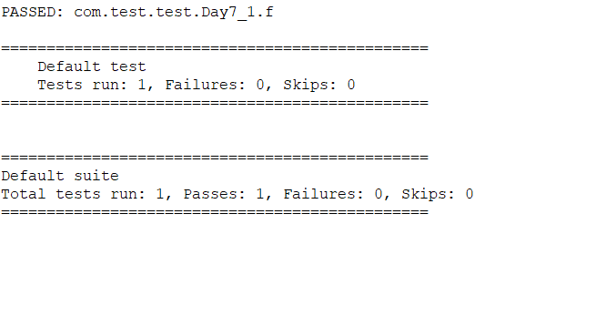

**Class Exercise – 2:**

**package** com.test.test;

**import** org.testng.Assert;

**import** org.testng.annotations.Test;

**public** **class** Day7_2 {

**int** a=100;

**int** b=25;

@Test(priority=4)

**public** **void** add() {

**int** c=a+b;

**int** addi=125;

System.***out***.println("Addition : "+c);

Assert.*assertEquals*(c, addi);

}

@Test(priority=3)

**public** **void** sub() {

**int** d=a-b;

**int** subt=75;

System.***out***.println("Subtraction : "+d);

Assert.*assertEquals*(d, subt);

}

@Test(priority=2)

**public** **void** mult() {

**int** e=a*b;

**int** multi=2500;

System.***out***.println("Multiplication : "+e);

Assert.*assertEquals*(e, multi);

}

@Test(priority=1)

**public** **void** div() {

**int** f=a/b;

**int** divs=4;

System.***out***.println("Division : "+f);

Assert.*assertEquals*(f, divs);

}

}

**OUTPUT:**

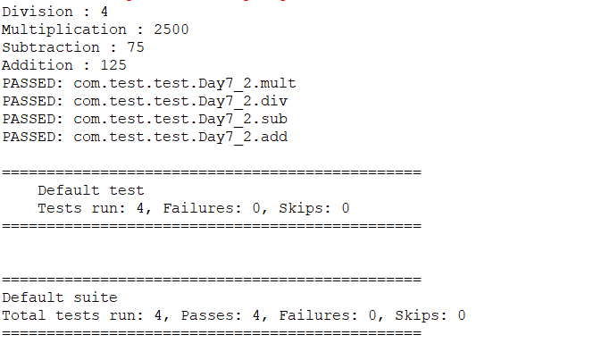

**Class Exercise – 3:**

**package** com.test.test;

**import** org.testng.annotations.Test;

**import** io.github.bonigarcia.wdm.WebDriverManager;

**import** org.testng.annotations.BeforeMethod;

**import** org.openqa.selenium.By;

**import** org.openqa.selenium.WebDriver;

**import** org.openqa.selenium.chrome.ChromeDriver;

**import** org.openqa.selenium.chrome.ChromeOptions;

**import** org.testng.Assert;

**import** org.testng.annotations.AfterMethod;

**public** **class** Day7_3 {

WebDriver d;

@Test

**public** **void** f() **throws** InterruptedException {

d.findElement(By.*xpath*("//*[@id=\"app\"]/div[1]/div/div[1]/div/div[2]/div[2]/form/div[1]/div/div[2]/input")).sendKeys("Admin");

d.findElement(By.*xpath*("//*[@id=\"app\"]/div[1]/div/div[1]/div/div[2]/div[2]/form/div[2]/div/div[2]/input")).sendKeys("admin123");

d.findElement(By.*xpath*("//*[@id=\"app\"]/div[1]/div/div[1]/div/div[2]/div[2]/form/div[3]/button")).click();

Thread.*sleep*(3000);

String actual="My Actions";

System.***out***.println(actual);

Thread.*sleep*(3000);

String expected=d.findElement(By.*xpath*("//*[@id=\"app\"]/div[1]/div[2]/div[2]/div/div[2]/div/div[1]/div/p")).getText();

Thread.*sleep*(2000);

Assert.*assertEquals*(actual,expected);

}

@BeforeMethod

**public** **void** beforeMethod() **throws** InterruptedException {

ChromeOptions co=**new** ChromeOptions();

co.addArguments("--remote-allow-origins=*");

WebDriverManager.*chromedriver*().setup();

d=**new** ChromeDriver(co);

d.get("https://opensource-demo.orangehrmlive.com/web/index.php/auth/login");

d.manage().window().maximize();

Thread.*sleep*(3000);

}

@AfterMethod

**public** **void** afterMethod() {

d.close();

}

}

**OUTPUT:**

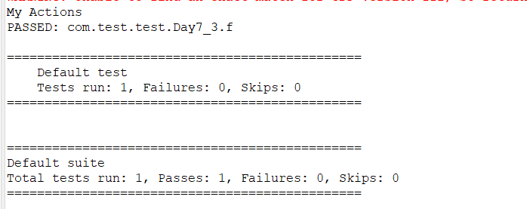

**Class Exercise – 4:**

package com.test.test;

import org.openqa.selenium.By;

import org.openqa.selenium.WebDriver;

import org.openqa.selenium.chrome.ChromeDriver;

import org.openqa.selenium.chrome.ChromeOptions;

import org.testng.Assert;

import org.testng.annotations.Test;

import io.github.bonigarcia.wdm.WebDriverManager;

public class Day7_4 {

WebDriver d;

@Test

public void login() throws InterruptedException {

ChromeOptions co=new ChromeOptions();

co.addArguments("--remote-allow-origins=*");

WebDriverManager.chromedriver().setup();

d=new ChromeDriver(co);

d.get("https://opensource-demo.orangehrmlive.com/web/index.php/auth/login");

d.manage().window().maximize();

Thread.sleep(4000);

d.findElement(By.xpath("//*[@id=\"app\"]/div[1]/div/div[1]/div/div[2]/div[2]/form/div[1]/div/div[2]/input")).sendKeys("Admin");

d.findElement(By.xpath("//*[@id=\"app\"]/div[1]/div/div[1]/div/div[2]/div[2]/form/div[2]/div/div[2]/input")).sendKeys("admin123");

d.findElement(By.xpath("//*[@id=\"app\"]/div[1]/div/div[1]/div/div[2]/div[2]/form/div[3]/button")).click();

Thread.sleep(3000);

String actual="My Actions";

System.out.println(actual);

Thread.sleep(3000);

String expected=d.findElement(By.xpath("//*[@id=\"app\"]/div[1]/div[2]/div[2]/div/div[2]/div/div[1]/div/p")).getText();

Thread.sleep(2000);

Assert.assertEquals(actual,expected);

System.out.println("Logged in");

}

@Test

public void logout() throws InterruptedException {

Thread.sleep(3000);

d.findElement(By.xpath("//*[@id=\"app\"]/div[1]/div[1]/header/div[1]/div[2]/ul/li/span")).click();

d.findElement(By.xpath("//*[@id=\"app\"]/div[1]/div[1]/header/div[1]/div[2]/ul/li/ul/li[4]/a")).click();

String txt="Login";

System.out.println(txt);

Thread.sleep(4000);

String etxt=d.findElement(By.xpath("//*[@id=\"app\"]/div[1]/div/div[1]/div/div[2]/h5")).getText();

Assert.assertEquals(txt, etxt);

System.out.println("Logged out");

}

}

**OUTPUT:**

